Performance Tracking Metrics Report

University Model

Jayesh Nagarkar

Akshay Patel

Rachit Singh

**Overview**

Reminisce the time when you were out there, researching about the colleges you received admits from. There were a plethora of universities and within each university, a plethora of courses for every student to choose from. Choosing a suitable college which streamlines with your career goals is one of the most important steps in a student’s career as it will pave the path for the prosperous future they are wiling to achieve. This process of choosing a course and university that would best align is quite overwhelming and difficult for a student. The aim is to use application engineering design paradigms and programming techniques to improve quality education offerings in University setting and hence improve the quality of life within the society via the means of education.

Thus, to focus on above deliverables, we have designed a Performance tracking metrics solution for a University which would help the university measure the quality of education they offer to their students. The application focuses on the fact that how by data collection, we can generate insights about the quality of education offered where quality means the alignment of courses with the current industry trends.

**Design Model**

The application has been designed for users to get a specialized feedback which tracks the growth of graduate students (Alumni) after course completion at the University till 5 yrs. In the job industry. Keeping in mind the different parameters and characteristics of the courses offered by the university, we have come up with an application that will help the students choose the most suitable course at the university.

The factors which are considered to design the application are:

1. Student’s Grade Point Average
2. Relevance of the courses taken with respect to current job.
3. Employment information (Organization, Designation, Salary, etc.)

The parameters mentioned above are important to calculate Performance Metrics as they contribute accumulatively towards the overall growth of a student over the years at their stay at the university and after graduation.

**The University Object Model**

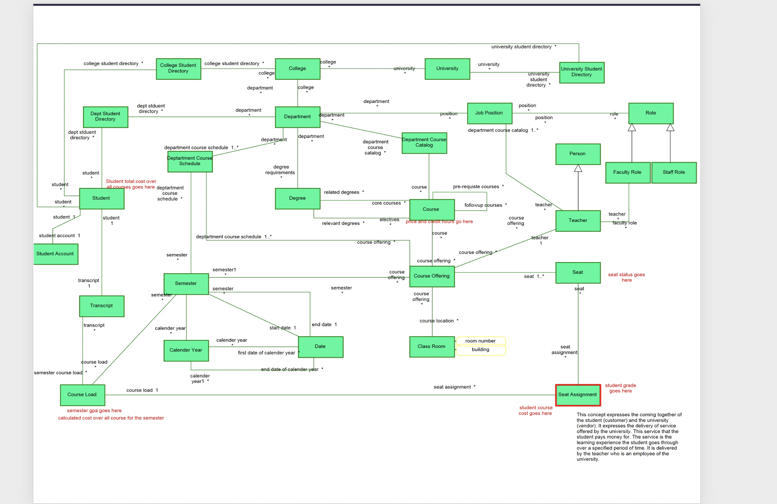

Keeping in mind the design paradigms of the University Model and the requirements of our ranking application, we made an object model with the necessary addition of components like Employment History, which will store the details related to Employment for Students and hence will be useful to track the growth of a student over years.

Here is an object model diagram of our proposed system which has the foundations of University model along with new components.

**Object Model Diagram**

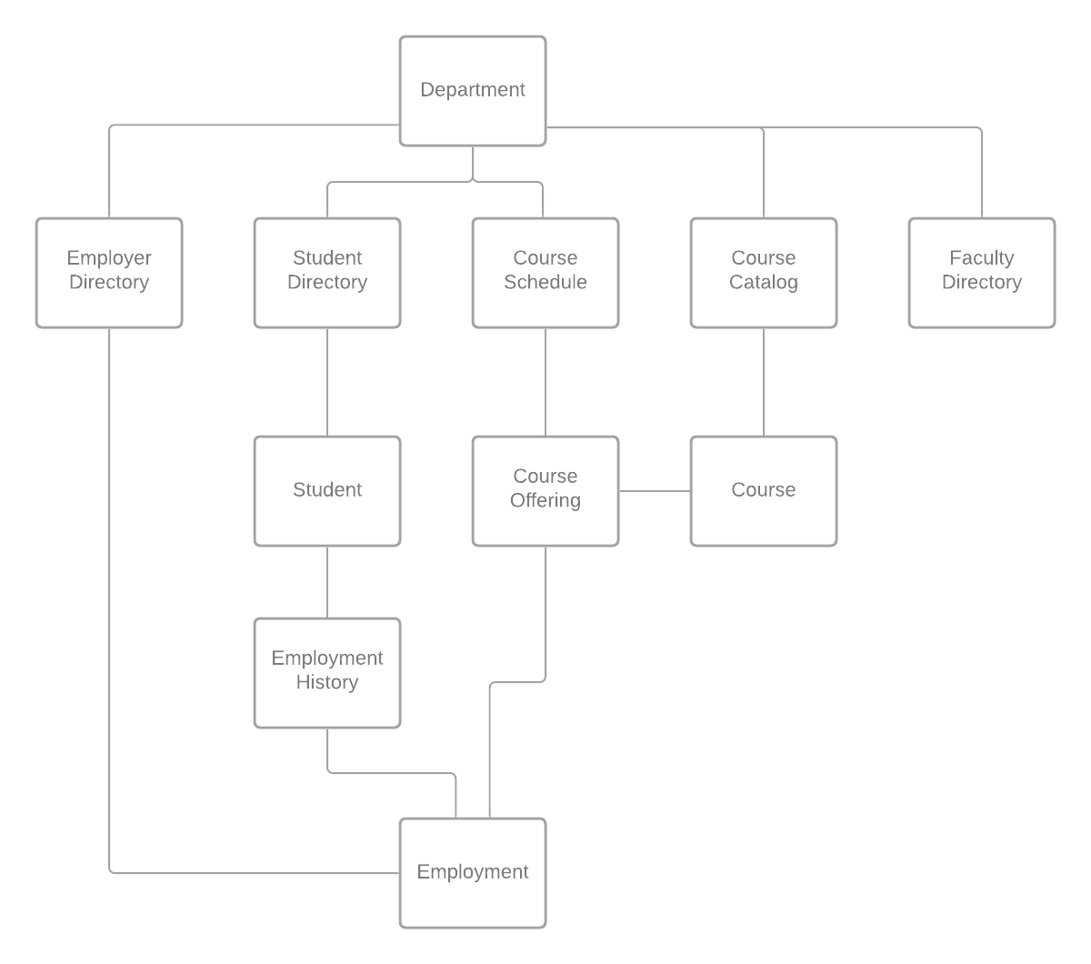

**UML DIAGRAM**

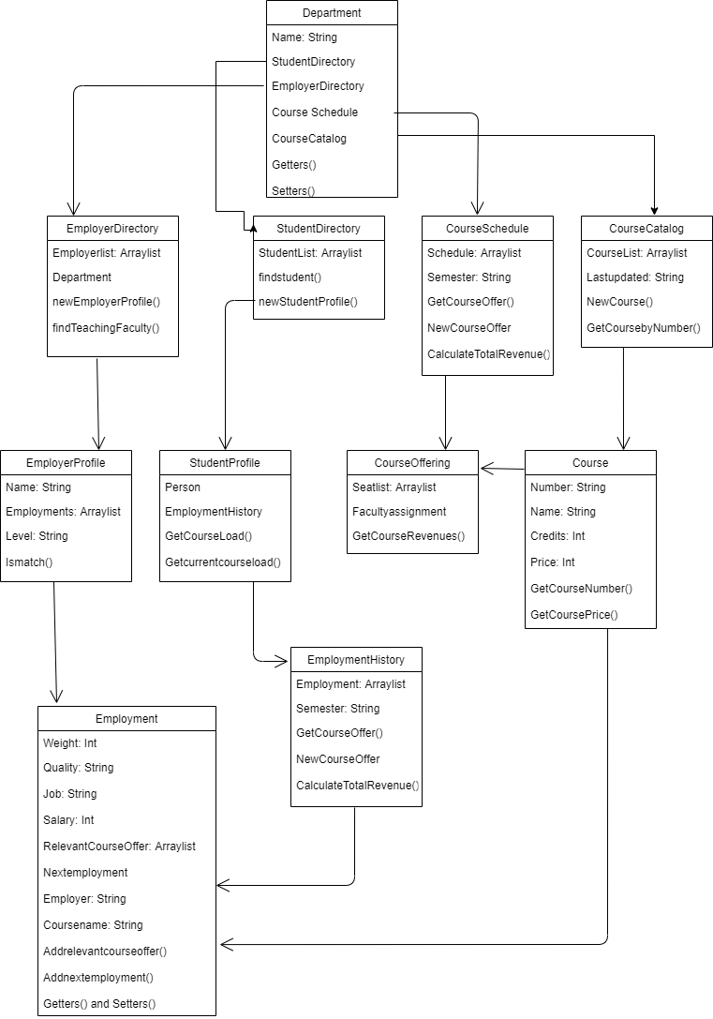

**University:**

This has all the information about the students, faculties, and courses. The roles and responsibilities include:

1. Maintaining the details of Students.
2. Maintaining the details of Faculties.
3. Maintain the data related to courses, data about courses registered by a student, number of students under a course, etc.

**Department:**

This component has all the necessary details about the departments present in a University.

**Course:**

This has all the relevant details about the courses offered within departments.

**Course Offering:**

This component has the specific details about the course. For example, the faculty assigned for this course, the classroom details, etc.

**Employer:**

This is one of the most important components as it stores the details about the employer which would be useful in our application model to determine the university-employer relationship with respect to a student’s growth and future.

**SEQUENCE DIAGRAM**

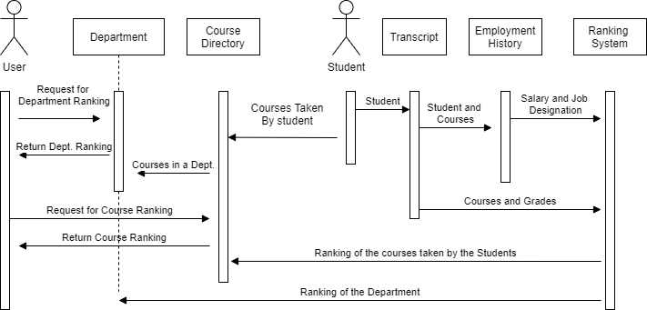

**DASHBOARD INTERFACES**

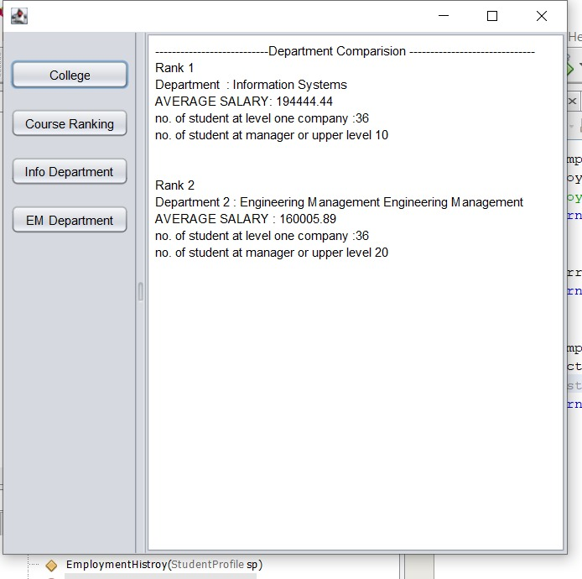

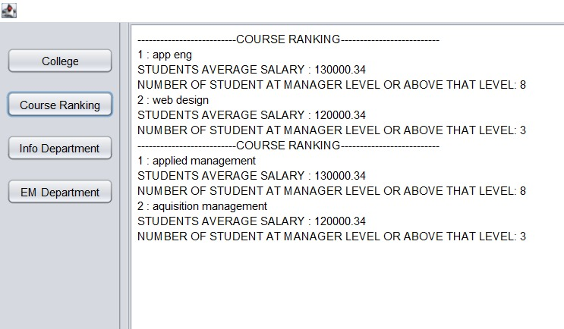

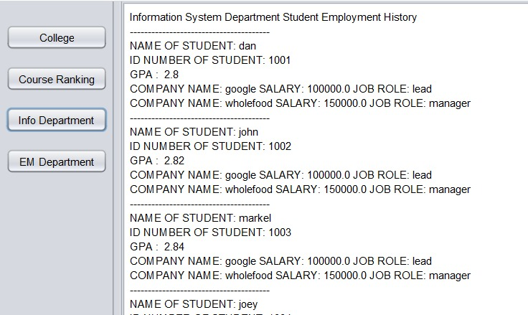

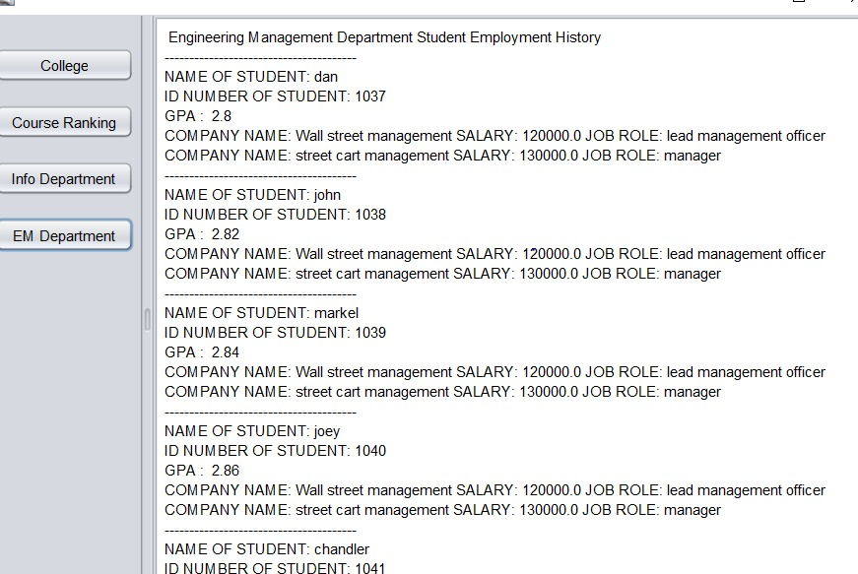

There are various considerations to the proposed solution to find out various parameters and rank them like:

We take in consideration 3 important factors to compare the departments in a University.

* Average Salary of the Student
* Designation of the Student in the company
* Ranking of the company

A general notion which we have applied to rank the parameters is that:

If the average salary of a student is > $150k, then they are assigned a higher rank than others.

If the Designation of the Student in organization is at a managerial level, then they are assigned a higher rank than students who are still at junior roles.

If a student is working at an organization like Google, then they are assigned a higher rank than a student working at an organization like Whole Foods.

We then calculate the overall factor where we assign certain weightage to each of the above-mentioned parameters. Salary contributes 50% to the overall ranking factor, with designation and organization contributing 25% each. We can then check the overall factor and analyze it to find out various parameters like, which Department was more successful, which courses were better, comparison of students within the department, etc.

So, if we want to check the ranking of the Departments in the University, we can take average salary, designation, and rank of the organization for the students and check how many students from each department have higher overall factor. The department which has more students with higher overall factor will the successful department.

For CourseOffer ranking, we consider the professional career of the students who took courses during their education period at the University. By professional career, we check the salary and designation of the student. The Course offer which provides better professional growth to higher number of students, will be the best course offer. We have shown two course offerings in our application.

Students within the same department can be compared on the same basis of salary, designation, and the organization they are working in. Higher the overall factor for a student, higher will be the rank of that student.

**Relationship Between GPA and Industrial Success**

After observing the data collected from our application, the major insight which comes out is that, although grades are important theoretically, but with respect to industrial success, ‘*Grades do not influence it’*. A good grade is not the only measure of subject knowledge or skillset. What matters is, passion, perseverance, innovation, desire to learn and work hard and think out of the box. As we can see from the data, students with a mediocre GPA are positioned at a higher designation than one would expect them to and yes, with a higher paycheck.

**University as an Intermediary between Students and Employers**

University is like a bridge, a bridge that a student must take to step into the professional, the industrial world and face the employers. For a student, who would be stepping their first foot in the professional world, it shouldn’t be the case where the world would seem completely alien to the student. Hence, the university should focus on providing education at a quality, where the courses offered would streamline with the industrial trends. For example, in an ever-involving technological world, a university shouldn’t teach a course that uses outdated technologies as that would not benefit the student who will represent the university once they are employed and hence, university’s credibility is at stake as well here. Employers would look out for students who have taken the relevant courses with which they could be benefitted from.

University acts as an intermediary broker by considering the three components at play here - Students, CourseOffering and Employer. Students give feedback about the courses which would be stored in the Course Offering component and similarly, employer would give feedback about the students who have joined their organization. So, a University would get feedback from the student about the courses offered which includes details about the faculty, etc. and University also receives feedback about the students who have graduated and joined various organizations, from the employer. In this way University acts as an intermediary between the students and the employers.

**Ideas and Solutions for k-to-12 educational systems in developing nations**

Taking cues from our very own digital application - we designed a ranking performance metrics application that would help users analyze and pick up the most suitable course according to their suit. A developing nation’s foundation are its youth, the students. A student will be successful in future if he/she is clear about their aim, know the market trends which would help the society develop and then use digital tools such as the one we designed to find the university and courses best fitted for them. There has been a steep increase in the usage of digital devices and the internet. Education has an important role in equipping individuals with these digital tools to enhance themselves and hence enhance the society. The very aim of this assignment was to utilize software engineering design techniques and instill them to create digital tools that would have a social impact and hence amplify the socio-technical aspect of engineering and education in the society. With the use of digital tools, one could learn digital skills and upskill themselves in these digital times and use the opportunities presented to enhance the society.